



Civic Engagement Form **– Councillor Louise Upton**

The Lord Mayor of Oxford is very keen to visit all aspects of the community during her term of office. Please use this form to request the Lord Mayor’s attendance at your event or function. It is of mutual benefit that this document is completed fully and returned at least four weeks prior to your event. Attendance cannot be guaranteed to invitations submitted at short notice.

On completion, please return to **civicoffice@oxford.gov.uk**.Should you have any queries relating to the completion of this form or if details change after returning the form, please contact the Executive Assistant, Lizzie Hawkins via the email address above**.**

|  |  |
| --- | --- |
| **EVENT DETAILS** | |
| **Name of Event:** |  |
| **Day and Date of Event:** |  |
| **Description of Event:**  Please include details of the purpose of the event and additional information about your organisation. |  |
| **Venue Address:**  Please include full postcode |  |
| **Event Start Time:** |  |
| **Event End Time:** |  |
| **Time you would like the Lord Mayor to arrive:** |  |
| **Time the Lord Mayor is able to depart:** |  |
| **Is the Lord Mayor able to bring their Consort or other guest?** |  |
| **Will refreshments be provided?**  If yes, please detail (e.g. drinks/buffet/dinner) |  |
| **Will car or bicycle parking facilities be available?**  If yes, please detail |  |
| **Please specify the dress code:** | Informal  Semi-formal  Black Tie |

|  |  |
| --- | --- |
| **DUTIES** | |
| **Do you require the Lord Mayor to open the event?** |  |
| **Do you wish the Lord Mayor to deliver a speech?** |  |
| **If yes, please give details on the subject matter:**  Please provide details/links to relevant information sources |  |
| **Will the press be invited?** |  |
| **Will a photo shoot be required?** |  |

|  |  |
| --- | --- |
| **KEY CONTACT / GUEST DETAILS** | |
| **Name of hosts who will greet the Lord Mayor:**  Please provide at least two names |  |
| **Contact on the day:** | Name:  Job Role:  Telephone:  Email: |
| **Contact(s) for further details** (if different from above)**:** | Name:  Job Role:  Telephone:  Email: |
| **Please give details of principal guests attending:** |  |

**Civic Office Holders 2025-26**

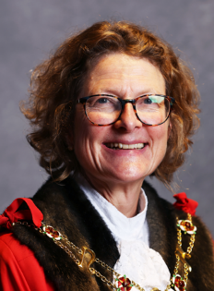**Lord Mayor of Oxford**

**Cllr Louise Upton**

Louise was educated at Grove Comprehensive School, Market Drayton, Shropshire. She obtained a BA (Hons) in Biochemistry from the University of Oxford (New College) and a PhD in Cell Physiology from University College London. She lived and worked in Paris for 3 years before returning to the UK to continue working as a research scientist at the University of Oxford. She teaches neuroscience to medicine and psychology students. Louise is the Council’s Champion for Cycling.

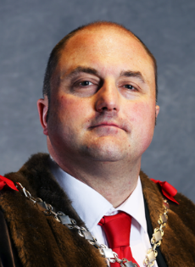**Deputy Lord Mayor of Oxford**

**Cllr Mike Rowley**

Mike Rowley is originally from Stafford but moved to Oxford in 1997 to study and now lives in Headington. He holds a law degree from Oxford University (Wadham College) and went on to study international Trade Union policy at Ruskin, and now works for Anneliese Dodds, MP for Oxford East. He has had the honour to represent Barton and Sandhills on Oxford City Council since October 2010. He was Lord Mayor in 2024-25.

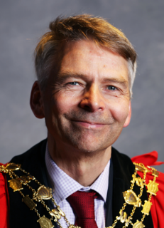

**Sheriff of Oxford**

**Cllr Andrew Gant**

Andrew is a British composer, singer, author, teacher and Liberal Democrat politician. He was organist, choirmaster and composer at Her Majesty's Chapel Royal from 2000 to 2013, and has published several books on musical subjects. Gant serves as a Liberal Democrat Councillor on both Oxford City Council and Oxfordshire County Council.

**Useful Information**

**Greeting the Lord Mayor** – The correct form of address and introduction is ‘The Right Worshipful, The Lord Mayor of Oxford, Councillor Louise Upton. The Lord Mayor should be greeted and addressed as ‘Lord Mayor’ until advised otherwise.

**Civic Regalia** – The Lord Mayor will wear her Chain of Office whilst undertaking formal engagements or will use the replica chain if it is deemed impractical to wear the authentic one. Robes are only permitted at formal ceremonies when the City Mace is in use.

**Lord Mayor’s Chosen Charities 2025-26**

|  |  |
| --- | --- |
|  | **The Gatehouse** has been supporting Oxford’s homeless community since 1988. The charity offers a wide range of free services and activities to adults who are homeless, vulnerably housed, on low or no income or simply looking for company and community from the drop-in community centre in Woodstock Road. It operates on an open-door basis, which means that everyone is welcome.  [www.oxfordgatehouse.org](http://www.oxfordgatehouse.org) |
|  | **TRAX** runs courses to engage young people aged 13 – 21 years old in Oxfordshire. The organisation aims to divert young people away from anti-social behaviour, crime and negative activities. It encourages the personal, social and educational development of all young people who come to the project so they can become positive and active members of their communities.  [www.traxeducation.com](http://www.traxeducation.com) |
| Logo 1 | **OXSRAD** is a unique facility, providing sports and recreation facilities for 400 disabled children and adults. It is located on the east of Oxford and serves many disadvantaged communities. OXSRAD also has many able-bodied members who use the facilities, and it is this integration of disabled and able-bodied that is the heart of the organisation.  [www.oxsrad.org](http://www.oxsrad.org) |

**Charitable Donations**

If you are a business, the Lord Mayor encourages you to support one of his charities (details below) with a modest donation. This can be made via cash, cheque or bank transfer. A member or the Civic Office will be in touch with further details regarding how you can make your donation. Please indicate your contribution below:

£50  £100  £250  £500  Other £

**Privacy Notice**

Oxford City Council Civic Office will primarily use your data for processing your request. We will only hold your information for as long as necessary for this purpose. All information is processed in accordance with our organisational privacy notice available from www.oxford.gov.uk/info. **I do not consent for my personal data being held**

**Thank You**

Thank you for completing this form.

Your invitation will be passed to the Lord Mayor and we will notify you of her attendance as soon as possible. Should the Lord Mayor not be available, your invitation will be redirected to the Deputy or Sheriff, in that order.