  Food Hygiene Rating Scheme:  Request for a re-visit |  | 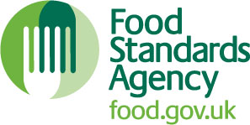

Notes for businesses:

- As the food business operator of the establishment you have a right to request a re-visit for the purposes of re-rating if you have taken action to rectify the non-compliances identified at the time of inspection.
- Please note that there is a charge associated with this service, which as of 1st April 2024 is £240.
- There is no limit on the number of requests you may make, however you must provide details of the improvements made with your request, including supporting evidence where appropriate. The re-visit will be carried out within three months of payment.
- The local authority officer will give you a ‘new’ food hygiene rating based on the level of compliance that is found at the time of the re-visit - you should be aware that your rating could go up, down or remain the same.
- To make a request for a revisit, please complete the form below and email to: foodsafety@oxford.gov.uk or send a hard copy to the Business Regulation Team, Planning and Regulatory Services, Town Hall, St Aldate’s, Oxford, OX1 1BX

Business details
Food business operator/proprietor

Business name

Business addresses

Business tel. number |  | Business email

Inspection details
Date of inspection |  |  |  |  | Food hygiene rating given

Action taken
Please describe the remedial action you have taken with reference to the issues identified in the inspection letter/report provided to you by your local authority with your score:
Compliance with food hygiene and safety procedures

Compliance with structural requirements

Confidence in management/control procedures

Please provide any other supplementary evidence (e.g. photographs, invoices, copies of relevant HACCP documentation etc.).

Signature
Name in capitals

Position |  | Date

